School of Science, Computing and Engineering Technologies

COS30045

LAB 4.1 Design Studio

Overview

In this lab you will be given a sample data set and asked to identify the different data and attribute types. You will also think about some questions about this data set that might be answered by a visualisation.

ardd_fatalities_Jan2020_0.xlsx (download from Canvas)

Download and review this data set before attempting this exercise.

1 Interpreting the data set

Complete the LAB 4.1 Quiz.

2 Visualisation Design

Think of three questions you would like to answer with that require a data visualistion.

For each data question you will need to consider the following:

Which data attributes (columns) do you need to answer this question?

Do you need to transform any of the data?

Does the data type change when you transform the data? If so how.

Make a sketch of how you think your visualisation might look and add to this document.

Your Question 1: Find the percentage of single, pedestrian, multiple crashes in 2020

Your answer here: Columns Years, crash type, crash id

We are combining and summarizing the crash type, crash id to find the numbers of each crash type then calculate the percentage base on total accident.

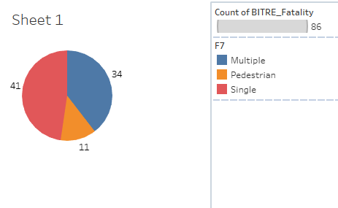

Your Question 2 : Find the different of the number of crash between days on week

Columns: Day of week, CrashID

We will find the number of crash base on crashID

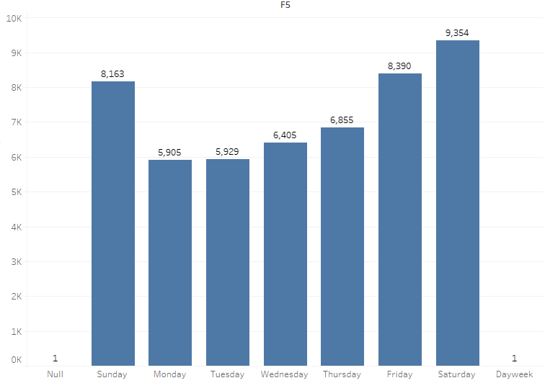

Your Question 3: Find the different of the number of crash between time of the day

Columns: CrashId, Time of the day

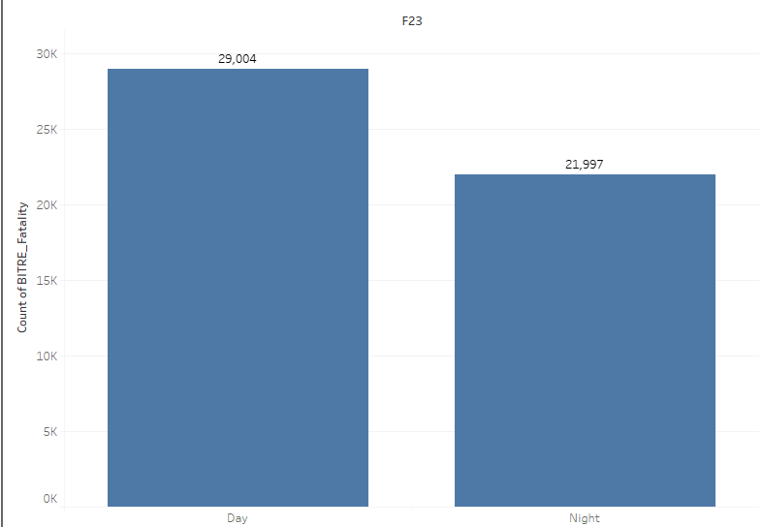

Same as the previous questions, we only count the number of accidents by the id

Include this file as evidence for your Demonstration 2